tags

surgical outpatients, Helen Joseph Hospital, Gauteng Health, Dr Nomathemba Mokgethi, Roodepoort, Rusty van Druten, Jack Bloom, Democratic Alliance, Gauteng, Office of the MEC, Kwara Kekana, Charlotte Maxeke Johannesburg Academic Hospital,

Elective surgeries become emergencies as Helen Joseph Hospital buckles under pressure

Surgical outpatients awaiting elective surgery at Helen Joseph Hospital are being subjected to long waiting times with no follow-up from the hospital, putting elderly and vulnerable patients at risk of emergency surgery by trainee surgeons - if they don't die while waiting.

While Gauteng Health MEC Dr Nomathemba Mokgethi has denied this, long waiting lists nevertheless sometimes turn these procedures into medical emergencies.

Roodepoort resident Rusty van Druten (75) was placed on a waiting list for a hernia operation at the hospital in March. News24 reports that he was turned away when he returned in April, after his conditioned worsened.

He suffered daily pain and discomfort, and had to lie down to get relief, as his bowel pushed down into his scrotum. He got no response from the offices of the hospital CEO or quality assurance when appealing for help for his worsening condition in May.

After waiting almost six months for surgery, in August he had to be admitted as an emergency with an incarcerated hernia. The hospital offered him the option of surgery by trainee surgeons or going back on the waiting list for an operation by a fully-qualified surgeon at a later date - even though the chief of surgery, Dr Bulabula, diagnosed his condition as an “emergency” the same morning.

Van Druten said that during his four-day stay, there was no hot water and for two days, no water at all. He said the toilets could not be flushed and overflowed with faeces and urine.

Jack Bloom, health spokesperson for the Democratic Alliance in Gauteng, said he was “horrified” that patients were given the option of immediate surgery by trainee surgeons.

“What quality controls are there with these trainees?” he asked.

The MEC’s office declined to explain its policy regarding this issue, or what quality controls were in place.

Bloom added that is was “unacceptable patients only get operated on when they become an emergency case”, or “died when their surgery is delayed”.

The MEC's office provided some figures, but was unable to provide waiting times for each of the disciplines, except to say that “the waiting time for urgent essential is two to three weeks and it drags to six to eight months for discretionary elective”.

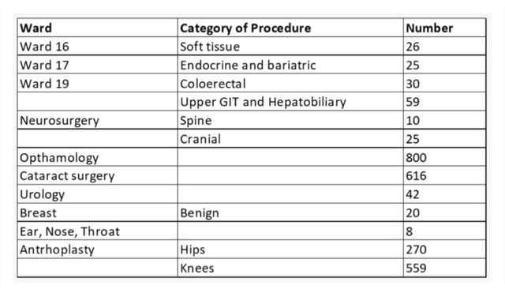

Spokesperson for the Office of the MEC Kwara Kekana said: “The waiting period has been severely affected by the intermittent restrictions … due to the COVID pandemic, the periodic inability to admit due to the acute shortage of surgical beds exacerbated by the closure of Charlotte Maxeke Johannesburg Academic Hospital, and various infrastructure issues in the theatre complex."

News24 article - Elective surgeries become emergencies as Helen Joseph Hospital struggles to cope (Restricted access)

<https://www.news24.com/news24/southafrica/news/elective-surgeries-become-emergencies-as-helen-joseph-hospital-struggles-to-cope-20211012>

See more from MedicalBrief archives:

Gauteng Health says it is tackling the cancellation of theatre procedures

<https://www.medicalbrief.co.za/gauteng-health-says-it-is-tackling-the-cancellation-of-theatre-procedures/>

Serious Adverse Events on the rise in Gauteng's worst hospitals

<https://www.medicalbrief.co.za/serious-adverse-events-on-the-rise-in-gautengs-worst-hospitals/>

Backlog of 7,000 surgery patients at Chris Hani Baragwanath

<https://www.medicalbrief.co.za/backlog-of-7000-surgery-patients-at-chris-hani-baragwanath/>